| Roll No.: A016,A018,A022 | Name: Varun K,Simran K, Kartik P |
| --- | --- |
| Class: B. Tech CsBs | Batch: 1 |
| Date of Experiment: 21-10-2022 | Subject: Mobile Computing |

# Design a system arch for transport and logistic management using WSN transportation of goods from factory to suppliers or end user

We have searched trough almost 5 research paper where in all the papers proposes a corresponding solution to the storage positioning problem and the safety of goods in transit. It broadens the whole logistics process of warehousing and distribution and designs a framework of intelligent logistics supply chain management system. The testing effect proves that this system has certain deployment reference significance and practical application value.

Logistics information has the function of supporting and guaranteeing the storage and transportation operations and related logistics management activities. Logistics supply chain information also has the general characteristics of logistics information, and the management of logistics supply chain should collect, organize, transmit, store, and utilize the relevant information of the whole process. The level of intelligent operation of the information system is limited by the scientific degree of the solution method of the related decision problems involved. This paper is based on RFID and WSN as the technical means and classification of logistics supply chain management. It provides a theoretical framework for a complete logistics information system architecture.

They analyze the application of wireless sensor networks and RFID technology in logistics supply chain management. It will also examine the design of the system based on the wireless sensor network and RF ID technology. Future development of this technology needs to overcome conceptual barriers and solve existing technical problems.

Also in the advent of technology, supply chain management has changed into a more

efficient and effective one. The rise of Wireless Sensor Network (WSN) made the processes involved a lot faster than before.

Lets first look at the basics of Supply chain management

A supply chain is the collection of steps that a business entity takes to transform raw components into the final product. This includes all the movements of inventory including storage, work-in-process inventory, and the finished goods from the point of origin to the point of consumption.



In planning, the manager must develop a strategy in order to address how a certain good or service can meet the needs of the customers. While methods for shipping are being planned, managers must also develop a set of pricing, delivery and payment processes with suppliers. The third stage is the making or the manufacturing of the products.

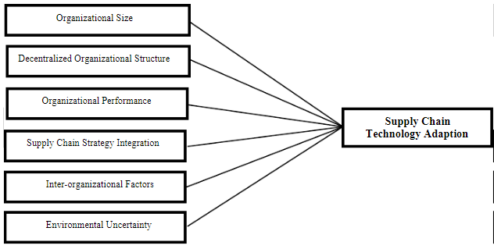

The WSN nodes can be attached to crates, roll containers, pallets and shipping containers to function as an active transport tracking device. These devices have the ability to actively monitor the transportation processes, and verify proper handling conditions of goods. This results in significant quality of service improvements and greater efficiency which in turn lead to lower transport cost.

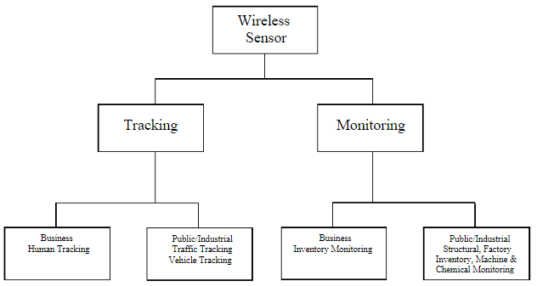

The above figure shows two major wireless sensor applications. This includes tracking and monitoring. Tracking deals with the maintenance of a constant difference in frequency between two or more connected components while monitoring deals with observing and checking the progress or quality of a thing over a period of time. Tracking application involves human indoor or outdoor tracking, traffic and vehicle tracking. Monitoring includes with inventory, structural, machine and chemical monitoring.

As of to conclude

Wireless sensor networks are of great help for many business entities when it comes to their supply chain management. This new fusion structure also provides new ideas to solve some key problems in warehousing logistics. It broadens the whole logistics process of warehousing and distribution and designs a monitoring system framework. In this paper, we define and classify the abnormal behavioral pose of cargo, use plus six-axis velocity sensors to obtain 3D acceleration data and pose angle of cargo in transit, and provide an algorithm for detecting behavioral pose. The method effectively solves the problem of redundant processing of cargo under normal conditions.

**References:**

1. [Optimization of Intelligent Logistics Supply Chain Management System Based on Wireless Sensor Network and RFID Technology](https://www.hindawi.com/journals/js/2021/8111909/)
2. [(PDF) Wireless Sensor Network for Intelligent Supply Chain Management](https://www.researchgate.net/publication/311674853_Wireless_Sensor_Network_for_Intelligent_Supply_Chain_Management)
3. [Logistics Management Systems: How Warehouse, Transportation, and Distribution Software Work](https://www.altexsoft.com/blog/business/logistics-management-systems-how-warehouse-transportation-and-distribution-software-work/)
4. <https://content.iospress.com/articles/journal-of-intelligent-and-fuzzy-systems/ifs179522>
5. Wang, J.: et al., “Wireless sensor network for real-time perishable food supply chain management”, Computers and Electronics in Agriculture, Elsevier, (2015)